A More Balanced World Outreach Program

Student Registration Form

Applicant requesting support services from A More Balanced World should be aware that the two most important criteria considered for acceptance in this program are:

- Applicant is enrolled in an educational institution and on track to obtain a degree/certificate (Proof of school enrollment is required)
- The support of ‘A More Balanced World’ is critical to the applicant’s ability to Stay in school and realize his/her maximum potential

Note: All personally identifiable information disclosed in this form will be considered confidential and referenced solely by A More Balanced World Outreach Program staff. This information will not be distributed to any other agency.
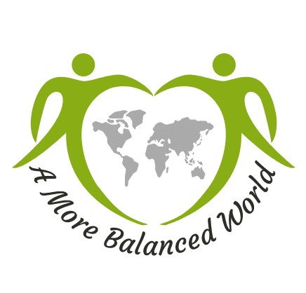

Personal Information

Last Name: |  | First Name: | M.I. | Date of Birth:
Gender: Female ---  Male ---  Non-binary --- |  | Marital Status: Single ---  Married --- |  | Driver’s License:
Mailing Address: | Street Address / P. O. Box: |  |  |  | Unit No.:
 | City: |  | State: |  | Postal Code:
Primary Phone No.: |  | Alternate Phone No.: | e-mail Address:

Family Information

Parent/ Guardian Name: |  |  | Phone No.:
Describe your current family/living situation; (with whom/where do you live?)

Are you currently employed? Yes --- No --- If the answer is Yes, Describe:

School Information

School Name:

Type of School:

Primary --- Secondary --- College/University --- Vocational --- Other --- Specify: --------

School Address: (Street Name, City, State)

Grade Level or  Year in College: | Major / Degree Objective, if in college: | No. of Units Currently Enrolled in:  Remaining Units to complete degree/program:
School Counselor Name & Contact Information:

Support Services Needed

Do you receive Financial Aid? Yes --- No --- If the answer is NO, provide reason:

How are your educational expenses currently being paid for?
(Note: receiving aid does not disqualify you from consideration of support)

…..

Tell us in what area(s) you need support:

Services | Description
Basic Physical Needs (e.g., food, clothes, hygiene products, transportation, mail service, etc.)

Transportation

Health Services (Medical, Dental, Vision, Emotional and Mental Health, etc.)
Educational / Career / Legal Counseling;
Other, (please describe)

Have you ever been convicted of a crime (felony or misdemeanor)? YES --- N0 ---
If you answered yes, please describe the circumstances: (note: a Yes answer to this question does not disqualify you from consideration of support)

…
How did you learn about ‘A More Balanced World Outreach Center’?

…

Parent / Legal Guardian Consent: I, the parent / legal guardian of ………………………., hereby grant permission for my child to participate in ‘A More Balanced World’ program. I agree to relieve ‘A More Balanced World’, Inc., its Board, Officers, Volunteers, and successors from any liability for injury to me or my child resulting from and/or in
connection with the activities in this program. I further agree to release and forever discharge the ‘A More Balanced World Outreach Program’ from any claim whatsoever which arises or may hereafter arise on account of any first aid, treatment, or service rendered in connection with my child participation.

I affirm that I am lawful parent/legal guardian of the above named minor and I understand and agree to the provisions of this consent and release as described in the preceding paragraph.

PHOTO RELEASE: A More Balanced World or its assigned agent has my permission to use images (digital, film, tape or video) of my child for promotion of A More Balanced World Outreach Program.

Client (or Parent/Guardian, if client is under 18 years of age)

Name: ….………….………

Signature: ………………………

Date: ………………………

Completed & Signed form should be emailed to: Outreach@AMoreBalancedWorld.Org

